Scale Drawing

Definition
# Source: AI Source: Provided by: [Data Path: Persons Table -> ID Column: 1, Name_En Column: Motasem Essam] -> From: [ChatGPT] on [7/17/2026]
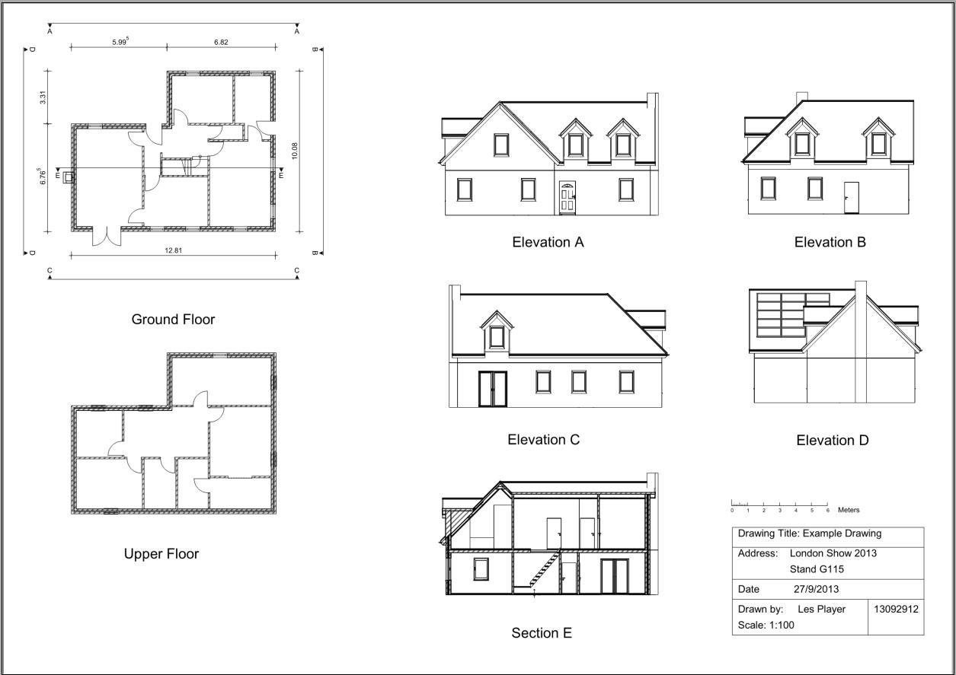
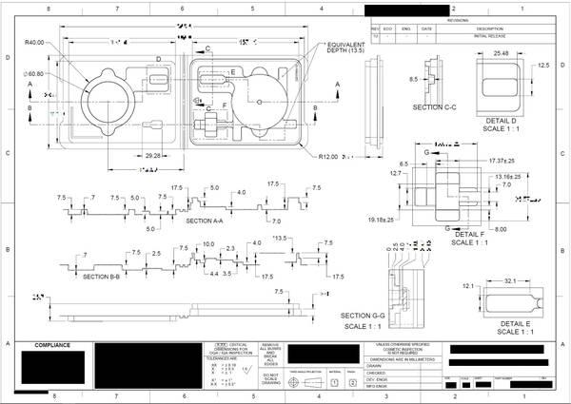
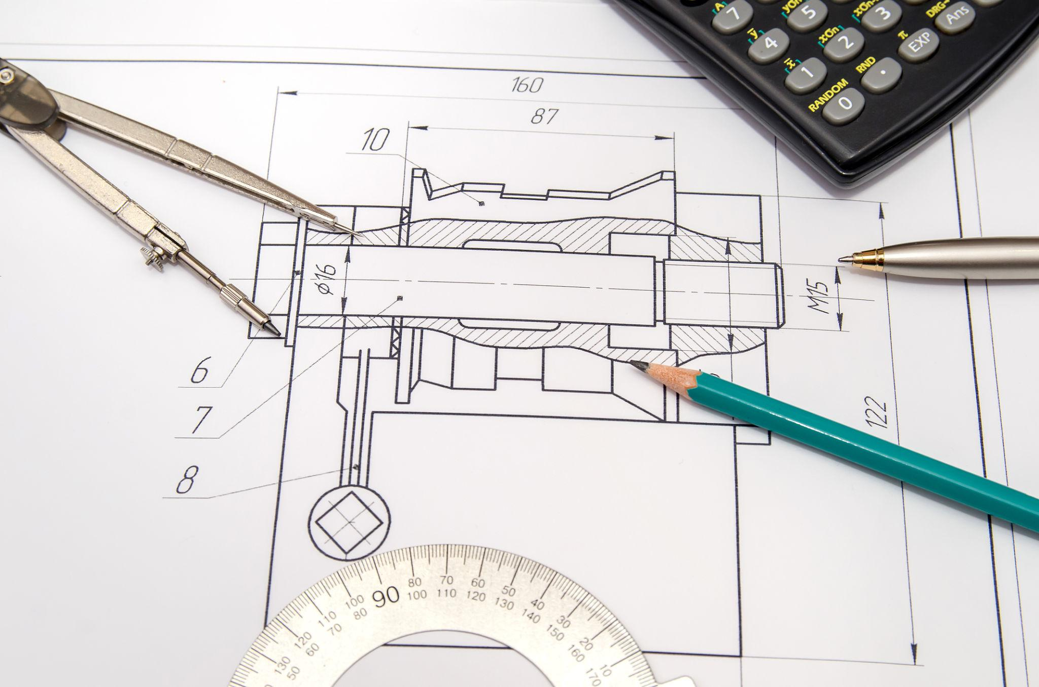
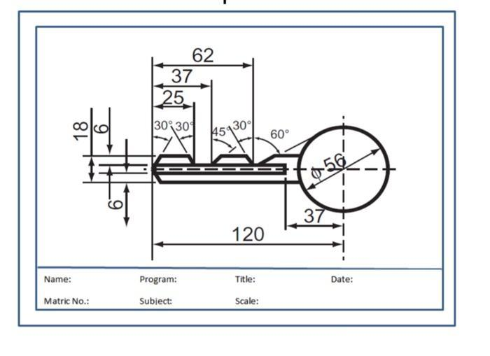
A Scale Drawing is a drawing of an object, map, building, or area in which all dimensions are reduced or enlarged proportionally according to a fixed scale.
The drawing preserves the shape, angles, and relative proportions of the original object while changing its size.

Purpose
# Source: AI Source: Provided by: [Data Path: Persons Table -> ID Column: 1, Name_En Column: Motasem Essam] -> From: [ChatGPT] on [7/17/2026]
Scale drawings are used to:
- Represent large objects on small paper.
- Enlarge small objects for detailed study.
- Produce engineering and architectural plans.
- Create maps.
- Design products and machinery.
- Assist in construction and manufacturing.

Principle
# Source: AI Source: Provided by: [Data Path: Persons Table -> ID Column: 1, Name_En Column: Motasem Essam] -> From: [ChatGPT] on [7/17/2026]
A scale drawing uses a constant ratio between the drawing dimensions and the real dimensions.
$$\text{Scale}=\frac{\text{Drawing Length}}{\text{Actual Length}}$$
Every measurement in the drawing follows the same ratio.

Types of Scale Drawings

1. Full-Scale Drawing (1:1)
# Source: AI Source: Provided by: [Data Path: Persons Table -> ID Column: 1, Name_En Column: Motasem Essam] -> From: [ChatGPT] on [7/17/2026]
The drawing is exactly the same size as the actual object.
Example:
- Mechanical parts
- Small components

2. Reduced Scale Drawing
# Source: AI Source: Provided by: [Data Path: Persons Table -> ID Column: 1, Name_En Column: Motasem Essam] -> From: [ChatGPT] on [7/17/2026]
The drawing is smaller than the real object.
Examples:
- Maps
- Building plans
- City layouts
- Engineering drawings
Common scales:
- 1:2
- 1:5
- 1:10
- 1:20
- 1:50
- 1:100
- 1:500
- 1:1000

3. Enlarged Scale Drawing
# Source: AI Source: Provided by: [Data Path: Persons Table -> ID Column: 1, Name_En Column: Motasem Essam] -> From: [ChatGPT] on [7/17/2026]
The drawing is larger than the real object.
Examples:
- Electronic components
- Microscopic objects
- Machine details
Common scales:
- 2:1
- 5:1
- 10:1
- 20:1

Scale Formats

Ratio Scale
# Source: AI Source: Provided by: [Data Path: Persons Table -> ID Column: 1, Name_En Column: Motasem Essam] -> From: [ChatGPT] on [7/17/2026]
Written as
$$1:n$$
Example
$$1:100$$
Meaning:
1 unit on the drawing represents 100 units in reality.

Representative Fraction (RF)
# Source: AI Source: Provided by: [Data Path: Persons Table -> ID Column: 1, Name_En Column: Motasem Essam] -> From: [ChatGPT] on [7/17/2026]
Expressed as
$$\frac{1}{100}$$
Meaning identical to
$$1:100$$

Graphic (Bar) Scale
# Source: AI Source: Provided by: [Data Path: Persons Table -> ID Column: 1, Name_En Column: Motasem Essam] -> From: [ChatGPT] on [7/17/2026]
A visual line divided into equal intervals showing actual distances.
Example:
0 10 20 30 m
|------|------|------|
Used mainly on maps.

Verbal Scale
# Source: AI Source: Provided by: [Data Path: Persons Table -> ID Column: 1, Name_En Column: Motasem Essam] -> From: [ChatGPT] on [7/17/2026]
Expressed in words.
Example:
1 cm represents 1 km

Common Scale Ratios
# Source: AI Source: Provided by: [Data Path: Persons Table -> ID Column: 1, Name_En Column: Motasem Essam] -> From: [ChatGPT] on [7/17/2026]
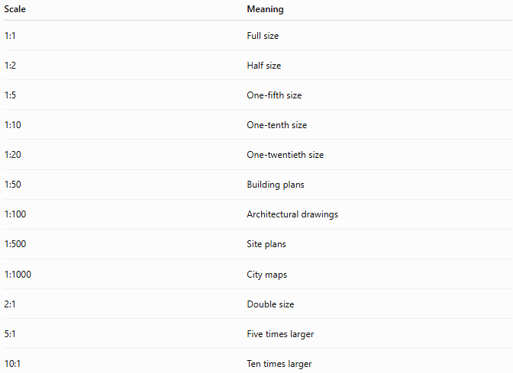
Scale | Meaning
1:1 | Full size
1:2 | Half size
1:5 | One-fifth size
1:10 | One-tenth size
1:20 | One-twentieth size
1:50 | Building plans
1:100 | Architectural drawings
1:500 | Site plans
1:1000 | City maps
2:1 | Double size
5:1 | Five times larger
10:1 | Ten times larger

Formula
# Source: AI Source: Provided by: [Data Path: Persons Table -> ID Column: 1, Name_En Column: Motasem Essam] -> From: [ChatGPT] on [7/17/2026]
Actual Length
$$\text{Actual Length}=\text{Drawing Length}×\text{Scale Factor}$$

Drawing Length
$$\text{Drawing Length}=\frac{\text{Actual Length}}{\text{Scale Factor}}$$

Example
# Source: AI Source: Provided by: [Data Path: Persons Table -> ID Column: 1, Name_En Column: Motasem Essam] -> From: [ChatGPT] on [7/17/2026]
Scale:
$$1:100$$
Actual wall length:
$$12\text{ m}$$
Convert to centimeters:
$$12\text{ m}=1200\text{ cm}$$
Drawing length:
$$\frac{1200}{100}=12\text{ cm}$$

Applications
# Source: AI Source: Provided by: [Data Path: Persons Table -> ID Column: 1, Name_En Column: Motasem Essam] -> From: [ChatGPT] on [7/17/2026]
Scale drawings are used in:
- Architecture
- Civil engineering
- Mechanical engineering
- Urban planning
- Interior design
- Cartography
- Product design
- Education

Advantages
# Source: AI Source: Provided by: [Data Path: Persons Table -> ID Column: 1, Name_En Column: Motasem Essam] -> From: [ChatGPT] on [7/17/2026]
Scale drawings:
- Preserve proportions.
- Simplify visualization.
- Save drawing space.
- Improve planning accuracy.
- Allow accurate measurements from drawings.

Limitations
# Source: AI Source: Provided by: [Data Path: Persons Table -> ID Column: 1, Name_En Column: Motasem Essam] -> From: [ChatGPT] on [7/17/2026]
Scale drawings:
- May lose fine details when greatly reduced.
- Require careful measurement.
- Can introduce errors if the scale is applied incorrectly.

Sources of Error
# Source: AI Source: Provided by: [Data Path: Persons Table -> ID Column: 1, Name_En Column: Motasem Essam] -> From: [ChatGPT] on [7/17/2026]
Instrument Errors
- Incorrect ruler calibration
- Printing distortion

User Errors
- Using the wrong scale
- Incorrect unit conversion
- Reading measurements inaccurately

Environmental Errors
- Paper expansion or shrinkage due to humidity
- Printer scaling errors

Comparison with Maps
# Source: AI Source: Provided by: [Data Path: Persons Table -> ID Column: 1, Name_En Column: Motasem Essam] -> From: [ChatGPT] on [7/17/2026]
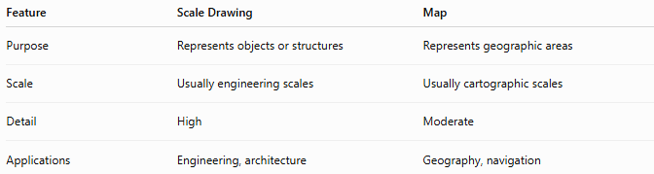
Feature | Scale Drawing | Map
Purpose | Represents objects or structures | Represents geographic areas
Scale | Usually engineering scales | Usually cartographic scales
Detail | High | Moderate
Applications | Engineering, architecture | Geography, navigation

Best Practices
# Source: AI Source: Provided by: [Data Path: Persons Table -> ID Column: 1, Name_En Column: Motasem Essam] -> From: [ChatGPT] on [7/17/2026]
- Use consistent units throughout calculations.
- Clearly label the scale on every drawing.
- Use appropriate scales for the level of detail required.
- Verify dimensions after scaling.
- Avoid measuring from distorted or improperly printed drawings.

Key Points
# Source: AI Source: Provided by: [Data Path: Persons Table -> ID Column: 1, Name_En Column: Motasem Essam] -> From: [ChatGPT] on [7/17/2026]
- A Scale Drawing represents an object proportionally.
- All dimensions use the same scale ratio.
- Scale formats include:
  - Ratio Scale
  - Representative Fraction (RF)
  - Graphic Scale
  - Verbal Scale
- Scale drawings are essential in engineering, architecture, mapping, and design.

Conclusion
# Source: AI Source: Provided by: [Data Path: Persons Table -> ID Column: 1, Name_En Column: Motasem Essam] -> From: [ChatGPT] on [7/17/2026]
A Scale Drawing is a proportional representation of an object or area created using a fixed scale ratio. It allows large objects to be reduced or small objects to be enlarged while preserving their proportions and geometry. Scale drawings are fundamental tools in engineering, architecture, cartography, construction, manufacturing, and education, enabling accurate planning, visualization, communication, and measurement.

